**PROGRAMS :** 

//To implement queue in c

//21co24 ETHAN MENEZES

#include <stdio.h>

int rear=-1; //variable declaration

int front=-1;

int arr[5];

int MAX=5;

//functions

void qinsert(int);

void qdelete();

void qdisplay();

int isEmpty();

int isFull();

void peek();

int main()

{

int x;

int temp;

do{

printf("1.Insert 2.Delete 3.Display 4.Peek 8.EXIT\n");

scanf("%d",&x);

switch(x)

{

case 1:printf("Enter the number to be inserted");

scanf("%d",&temp);

qinsert(temp);break;

case 2:qdelete();break;

case 3:qdisplay();break;

case 4:peek();break;

case 8:printf("exiting \n");break;

}

}while(x!=8);

return 0;

}

void qinsert(int elem)

{ if(isFull())

{

printf("Queue has overflown!\n");

}

else{

if(front==-1) //checks for

{

front+=1;

}

rear+=1;

arr[rear]=elem;

}

}

int isFull()

{

if(rear==MAX-1)

{

return 1;

}

else

{

return 0;

}

}

int isEmpty()

{

if(front>rear||front==-1)

{

return 1;

}

return 0;

}

void qdelete()

{

int temp;

if(isEmpty())

{

printf("Queue underflow!\n");

}

else

{

temp=arr[front];

printf("Removing %d from the queue\n",temp);

front+=1;

}

}

void qdisplay()

{

if(isEmpty())

{

printf("Queue underflow\n");

}

else

{

printf("The elements are\n");

for(int i=front;i<=rear;i++)

{

printf("%d\t",arr[i]);

}

printf("\n");

}

}

void peek(){

if(isEmpty())

{

printf("Queue is empty\n");

}

else

{

printf("The peek value is %d\n",arr[front]);

}

}

Input/Output:

Inserting elements in the queue and displaying it:

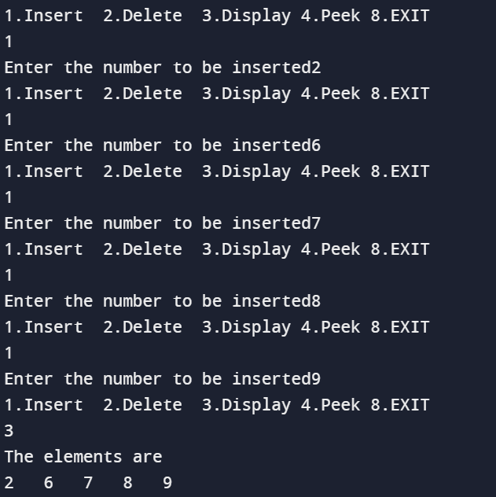

Deleting elements in the queue and displaying it:

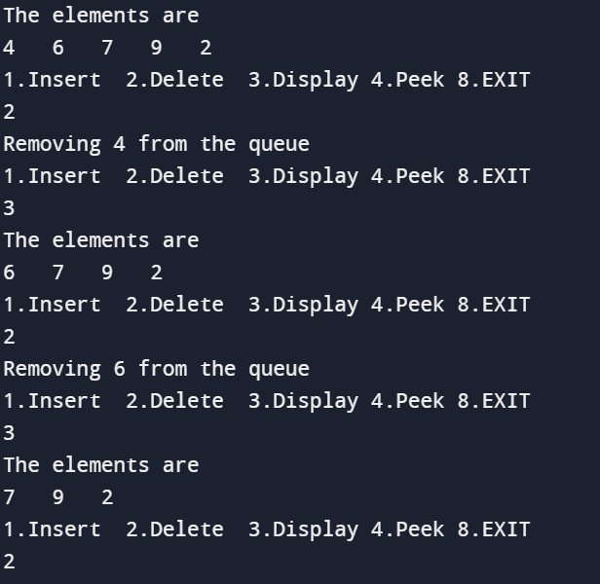

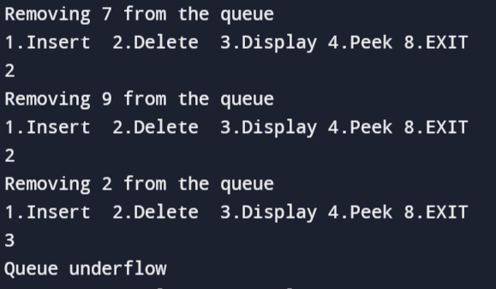

Peek element of the queue:

